kartris

2.2.1. Setup a new web project in Visual Studio
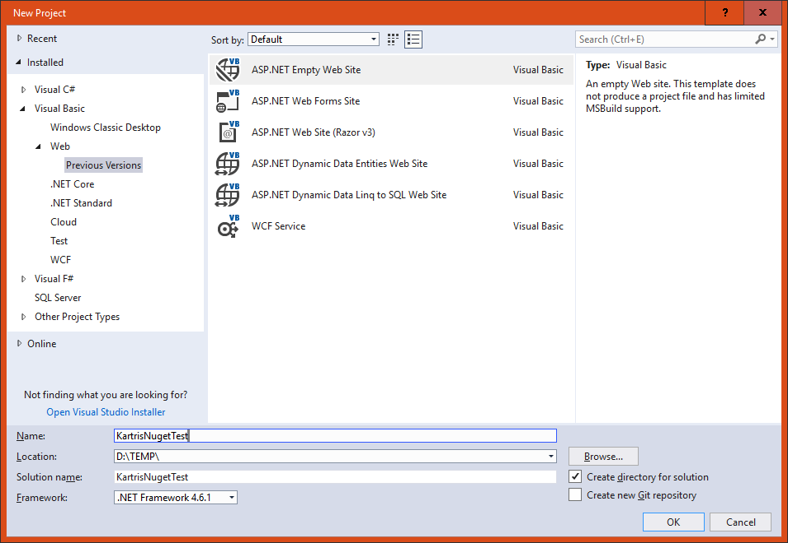
Select from the left hand panel.
Then choose in the main content area, and choose a name and location for your project. The version of the framework isn't so important, as that should be set later when we pull the files in. But you must have at least .NET 4.6 installed.
Next, remove any files and folders that Visual Studio 'helpfully' adds to the web site, so it really is empty.

